**Centra Zoo**

*Developer Guide*

|  |  |  |
| --- | --- | --- |
| **Supervisor.** | **Miss Muniba** | |
| **Batch.** | **2110F1** | |
| **Group.** | C | |
| **Serial No.** | **Enrollment Number** | **Student Name** |
| 1. | **1338868** | **Tayyab faisal** |
| 2. | **1338683** | **Shoaib** |
| 3. | **1340163** | **Haris** |
| 4. | **1340159** | **Shaffan** |

**1.Home** (*the zoo.html*)

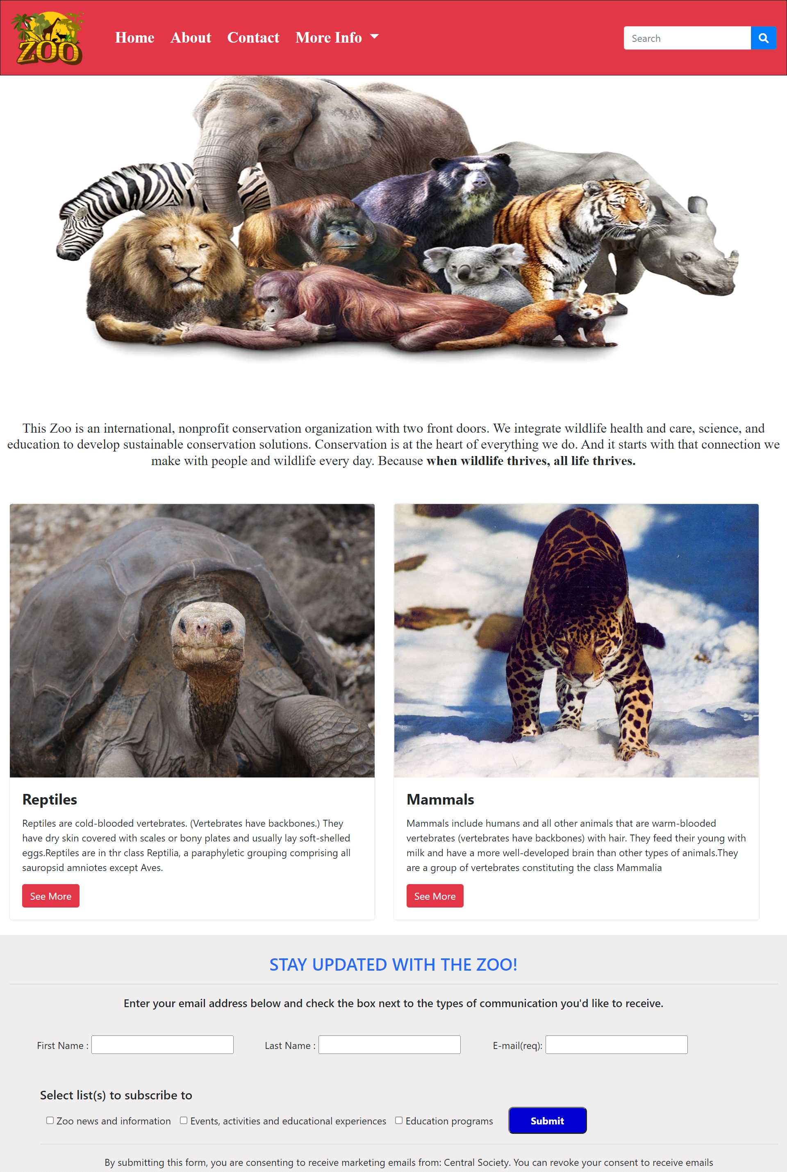

***Figure 1: Home page to Zoo***

“LET'S START A JOURNEY WITH US” .

**Code of Home page**

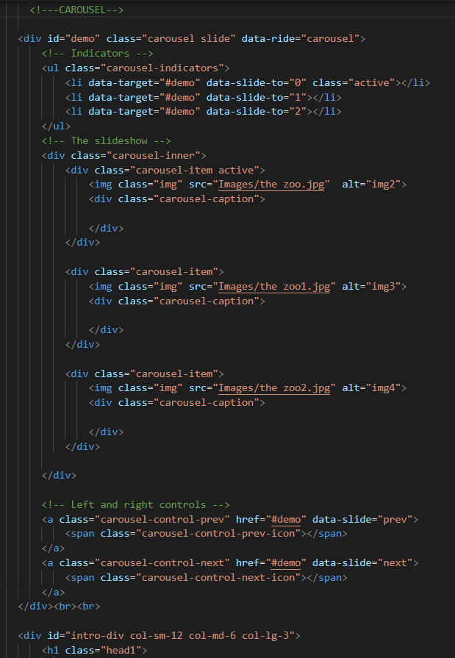

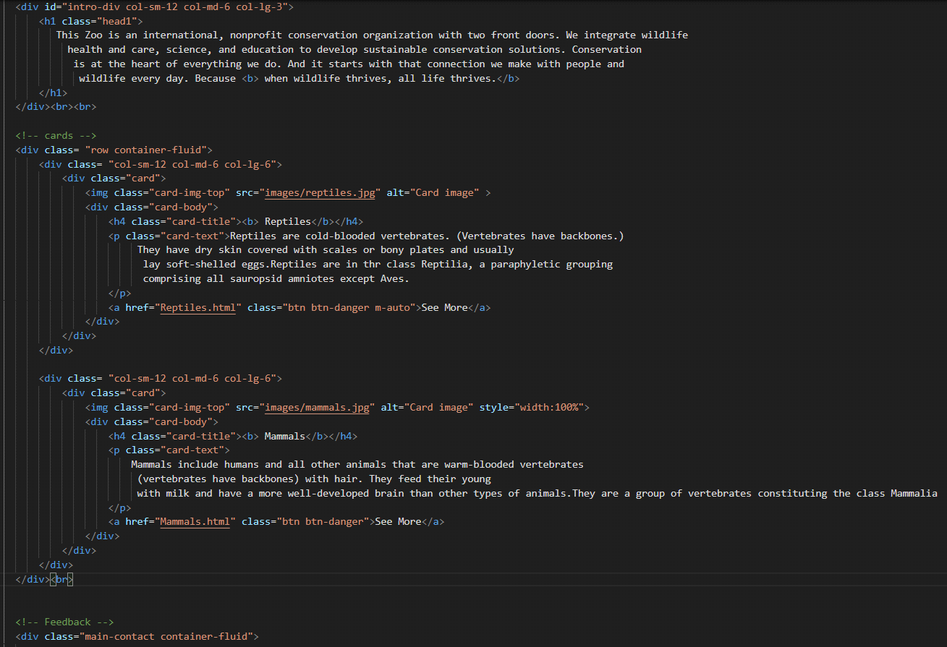

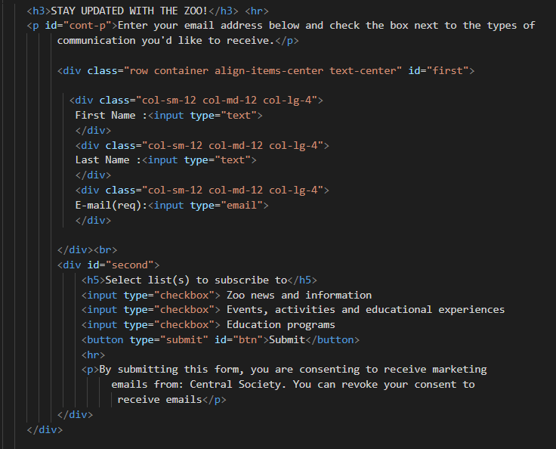

**2.Navbar (the zoo.html)**



***Figure 2: Navbar***

We have given four essentials. By clicking any of the essential’s and redirect to the linked page. (the zoo.html)

**Code of Navbar**

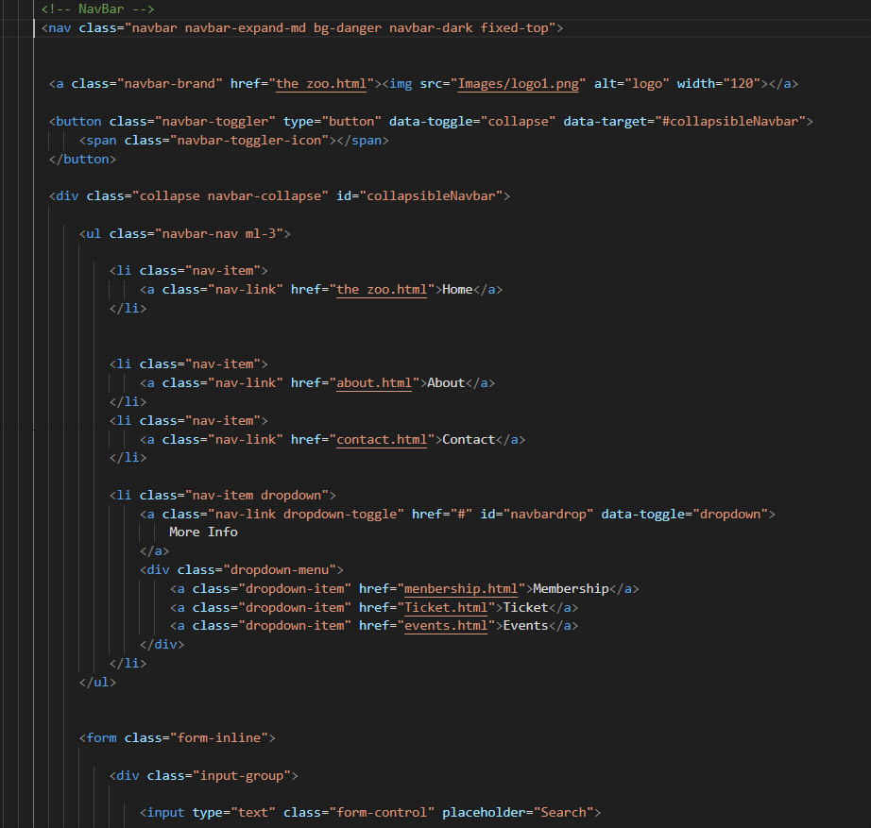

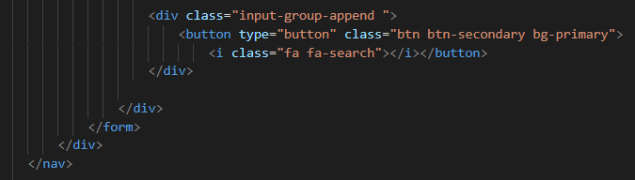

**3.About us (about.html)**

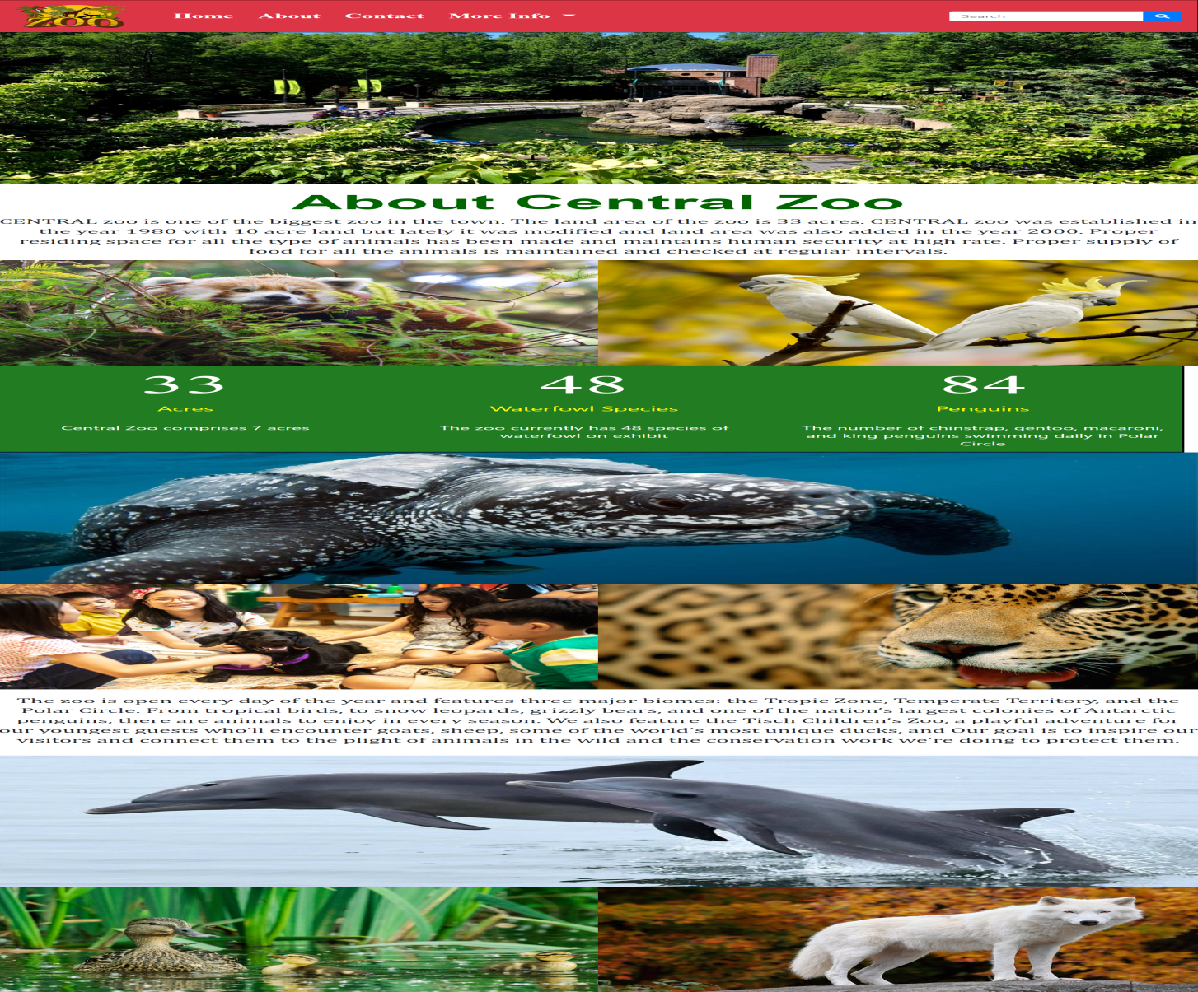

 ***Figure 3: About us***



 Central Zoo comprises 33 acres.

 The zoo currently has 48 species of waterfowl on exhibit

 84 type of peniuns.

***Code of About Us***

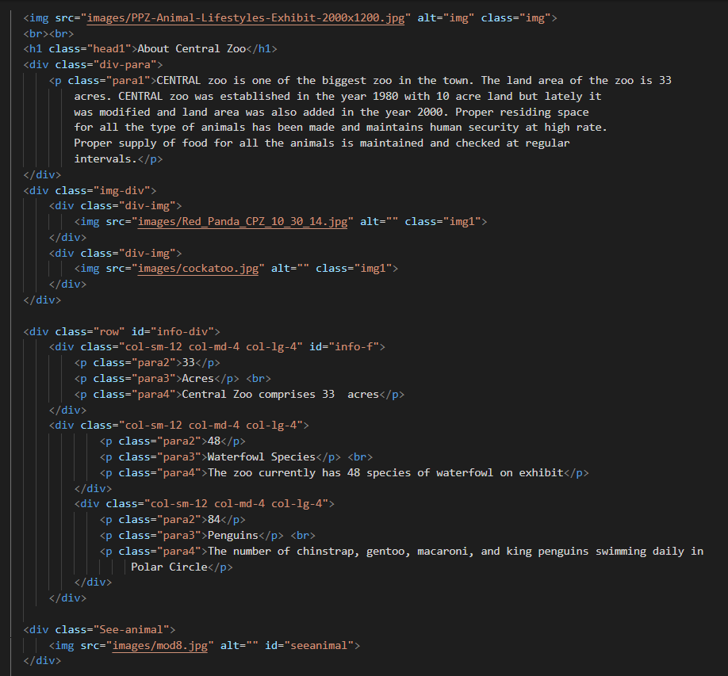

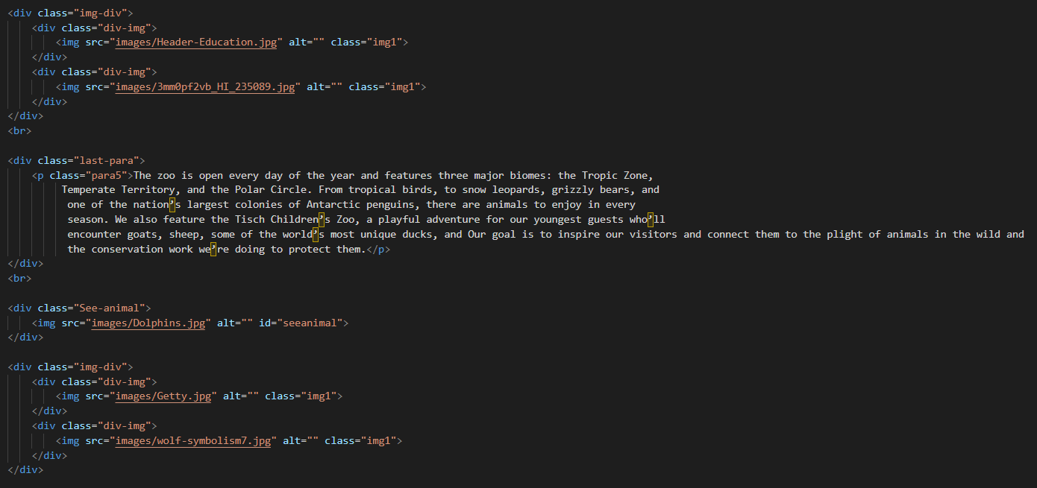

**4.Reptiles (Reptiles.html)**

Below is the page of Reptile.

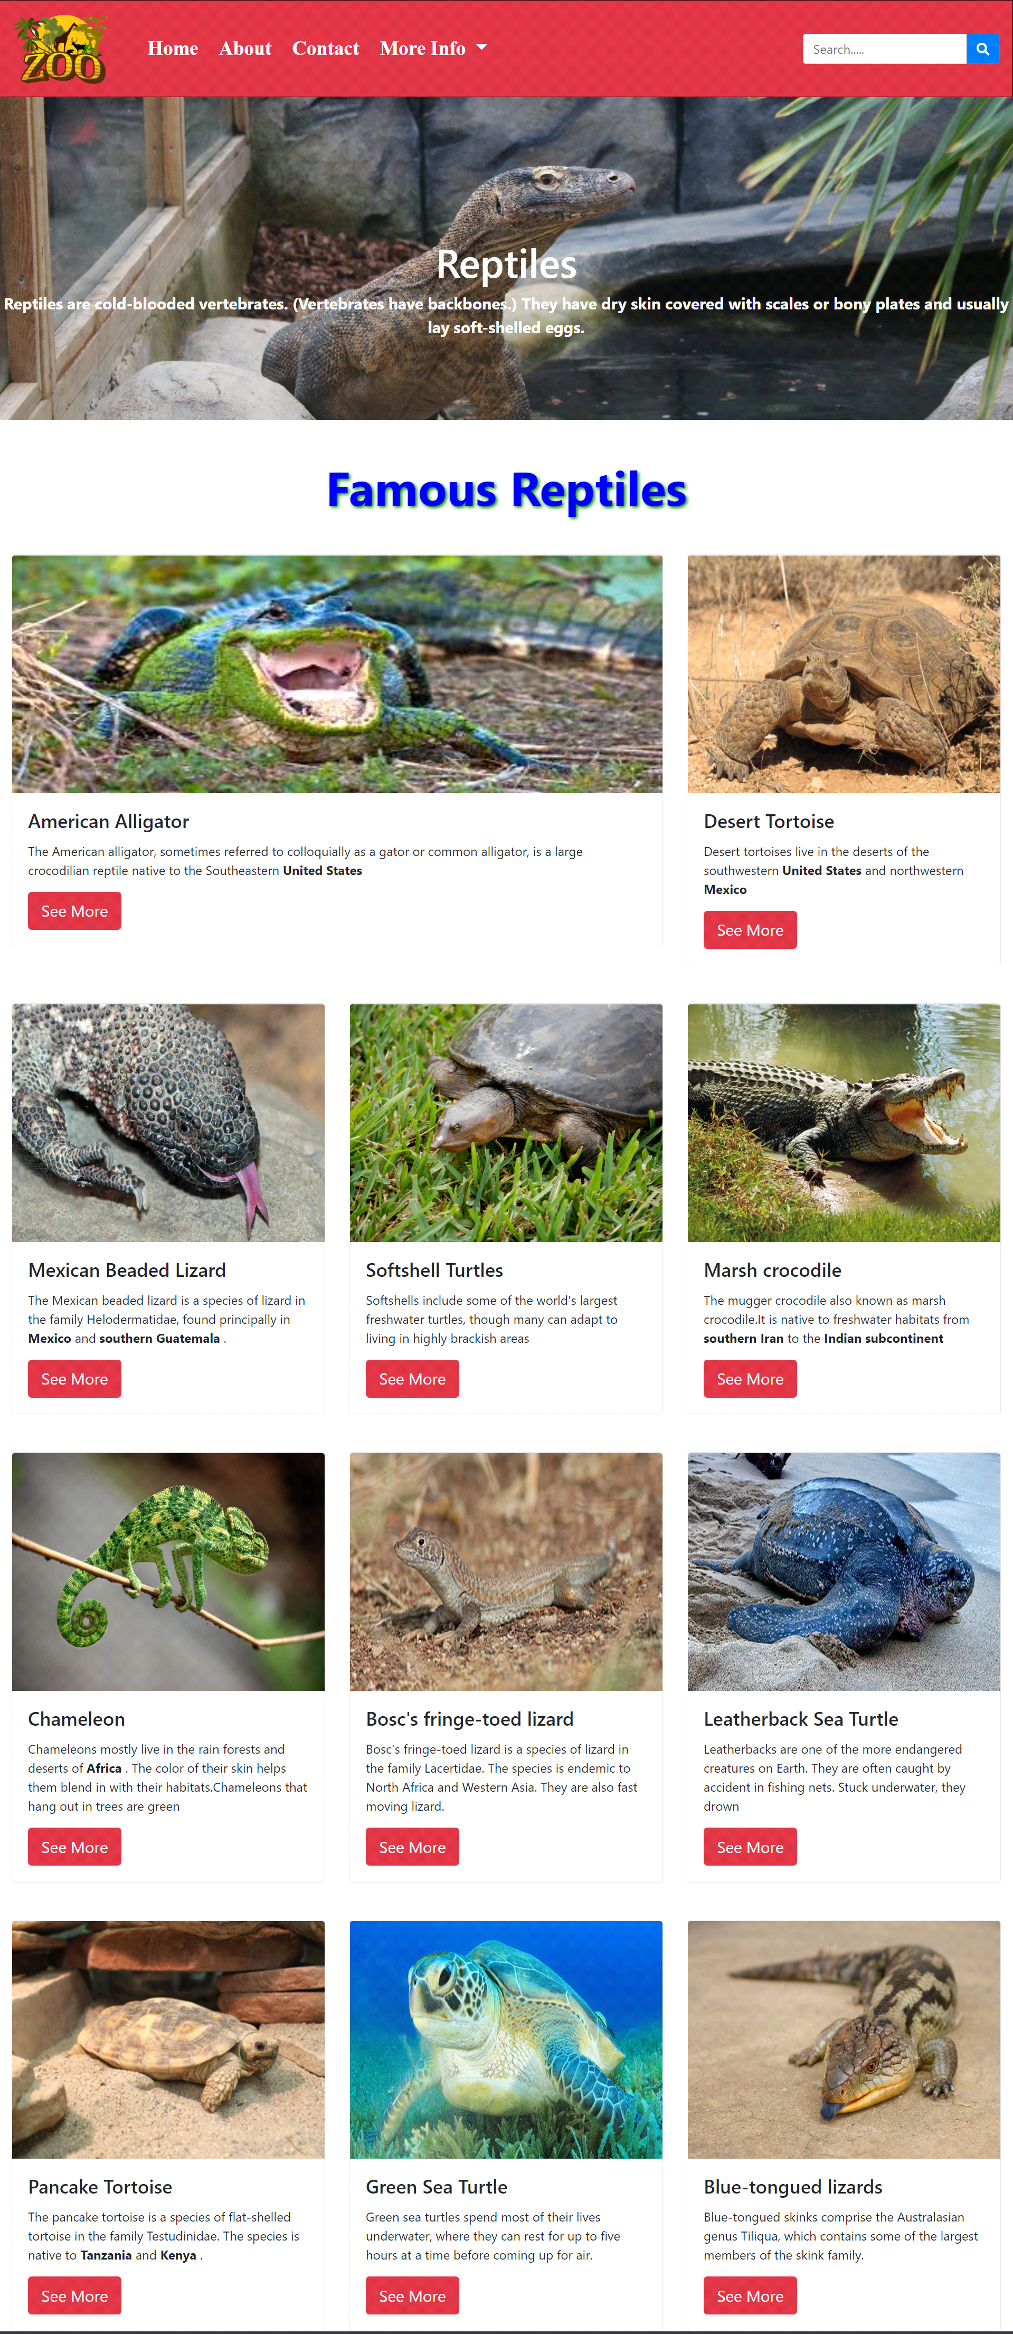

***Figure 4: Reptiles***

*We have mentioned our some famous reptiles & its characteristics.*

***Code of Reptiles***

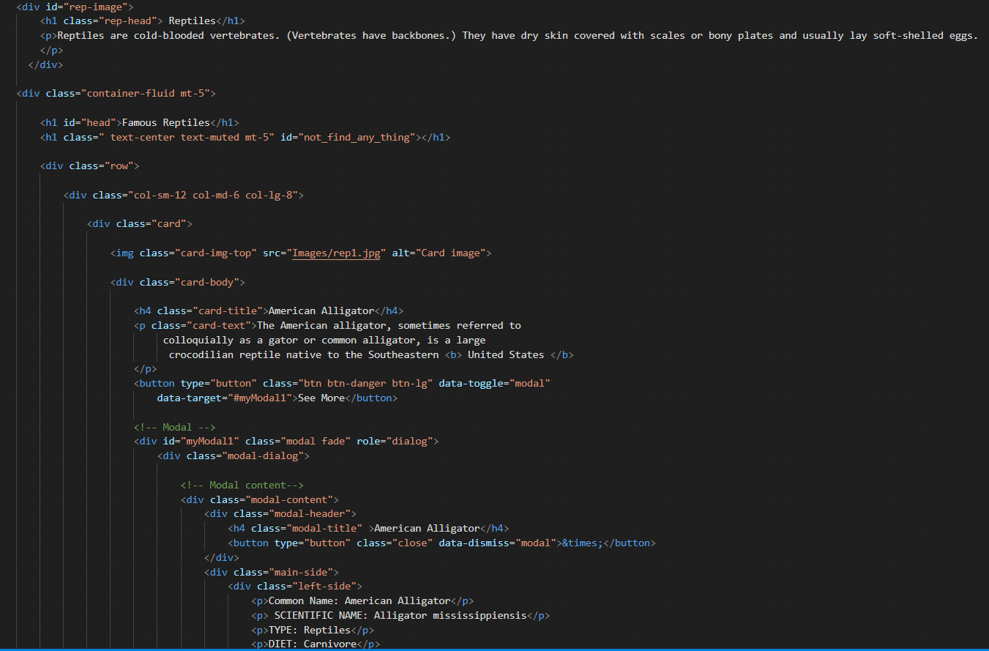

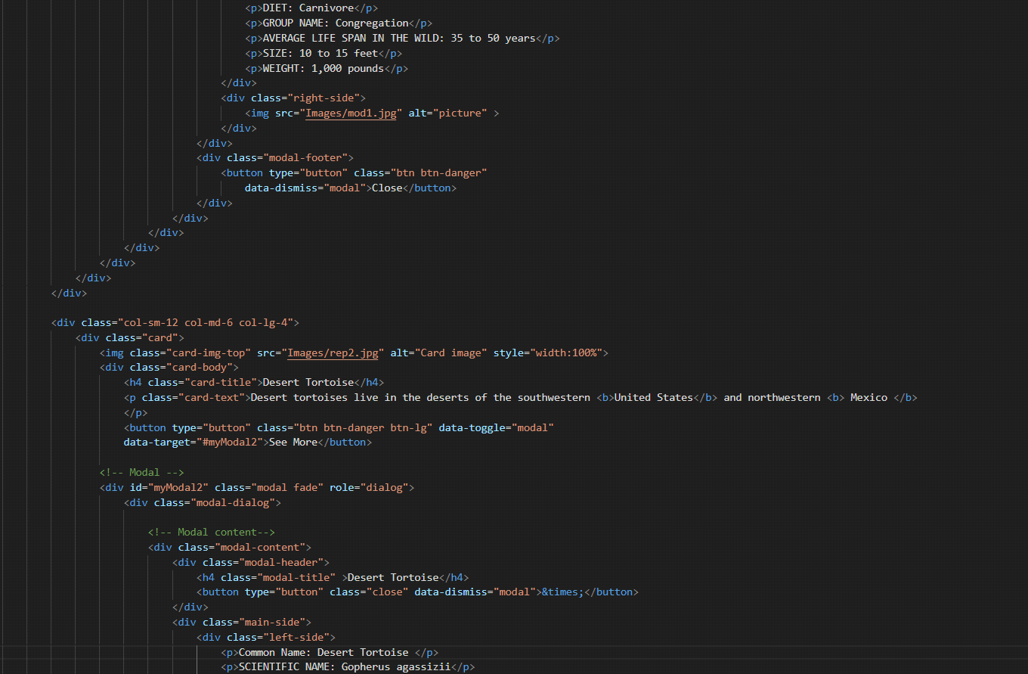

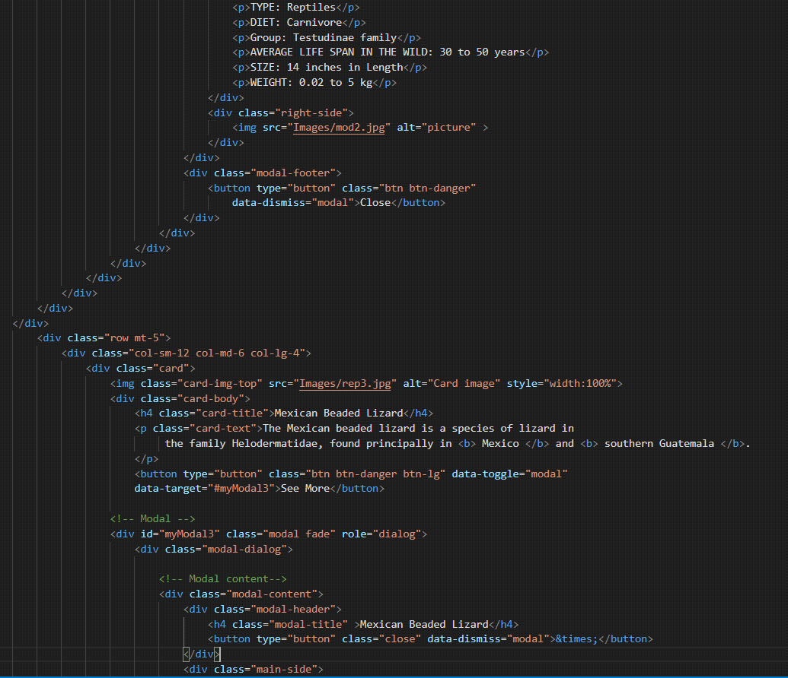

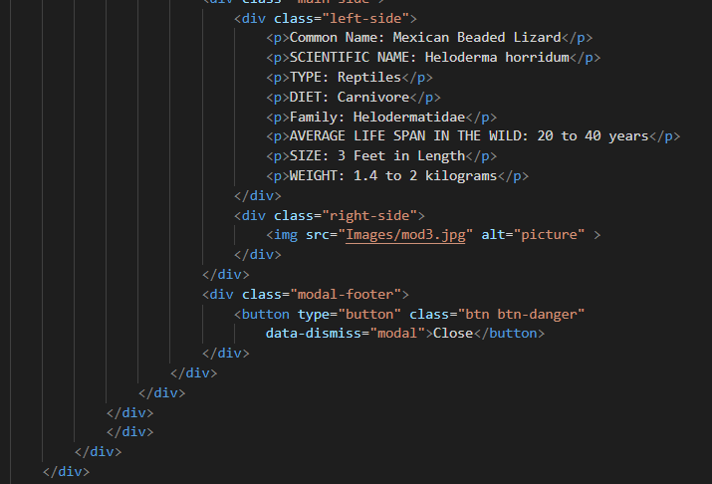

***5.Mammals (index (1).html)***

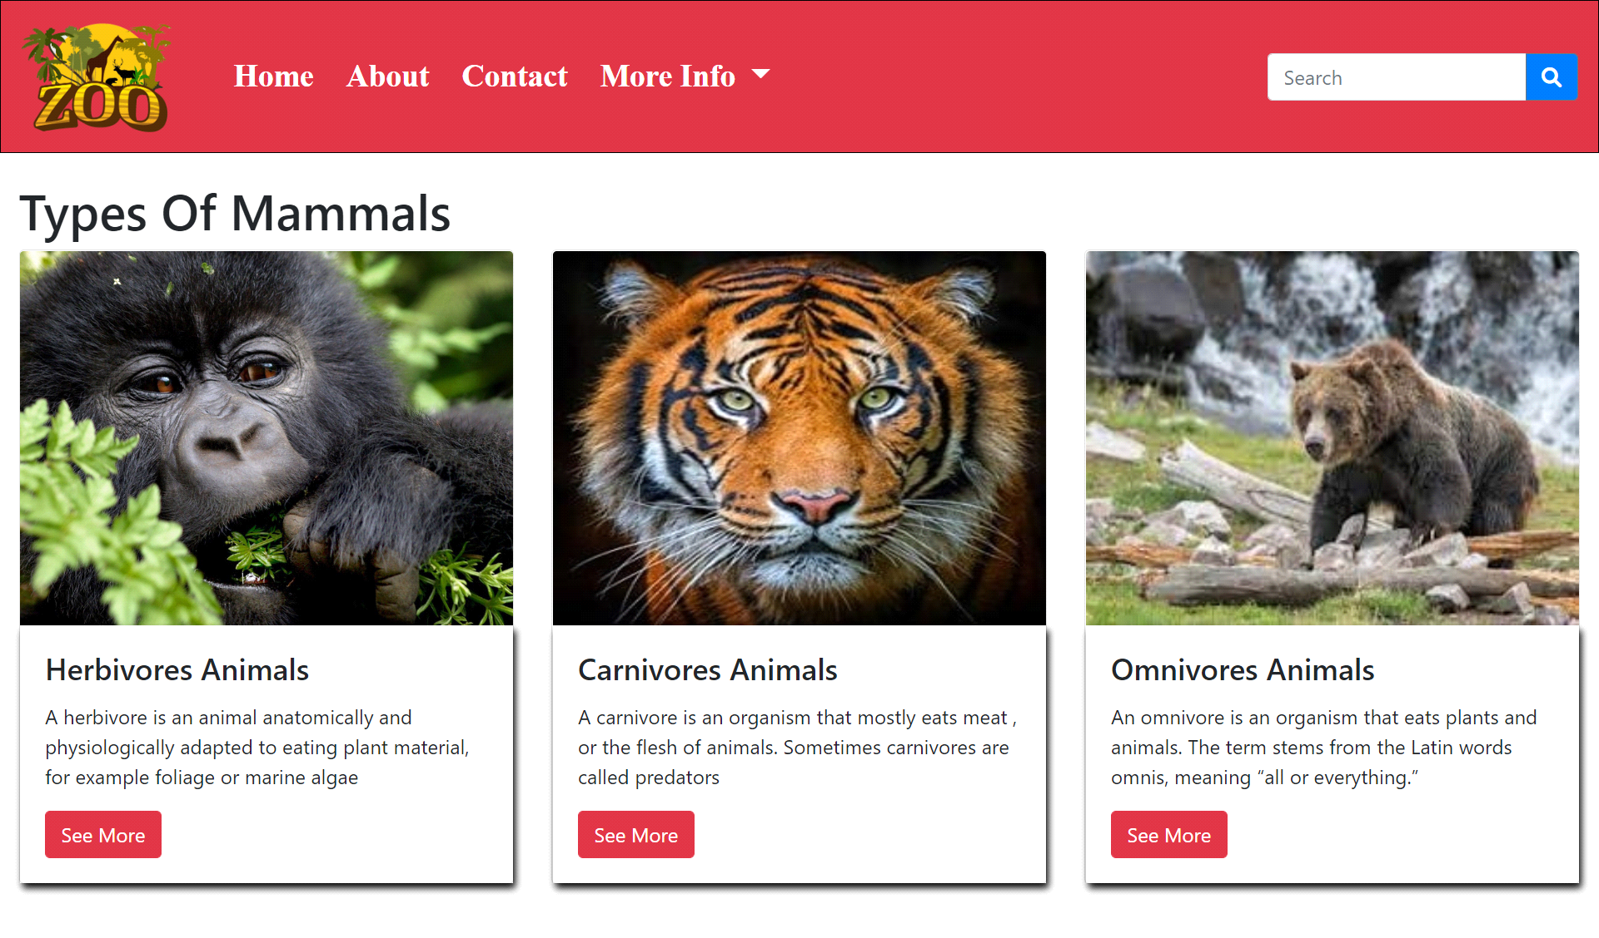



***Figure 5: Mini Aquarium Species***

***Description:*** *Mammals are a group of vertebrates constituting the class Mammalia,.*

***“Category of mammals”***

*We have given three category of mammals.*

*And provide modal to highlight the name and characteristics so that people who are visiting our website can gain knowledge.*

* ***Carnivores***
* ***Harivores***
* ***Omnivores***

***Code of Mammals***

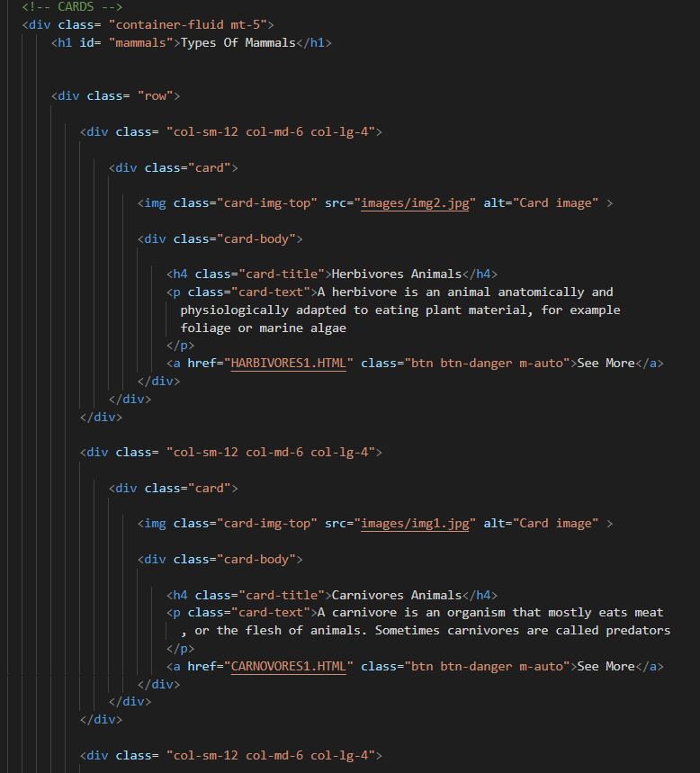

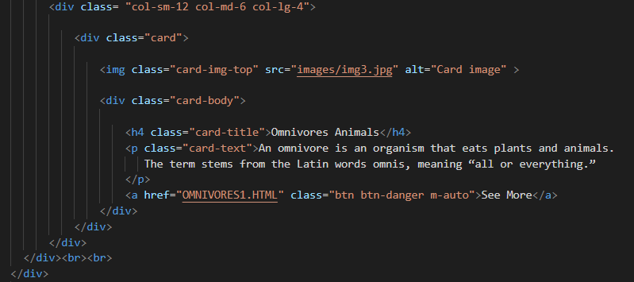

***6.Events (events.html):***

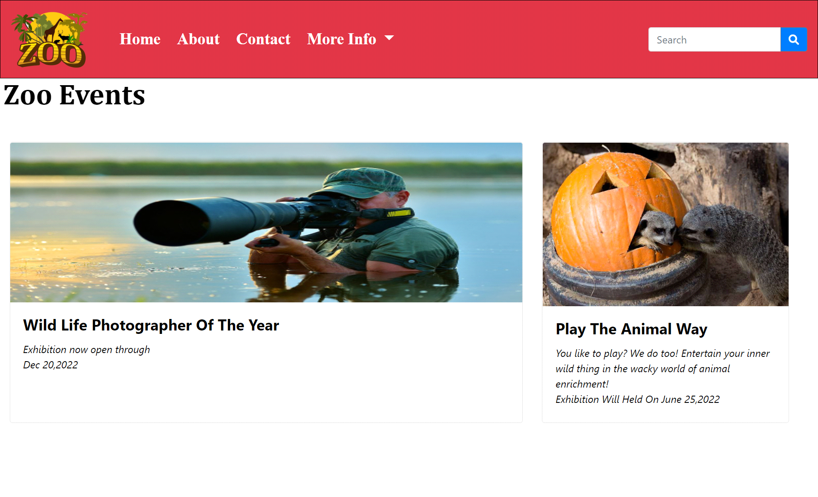

***Figure 6: Upcomming Events***

 Wildlife photographer of the year in Dec 20,2022

 Play the animal way in June 25,2022

***Code of Events***

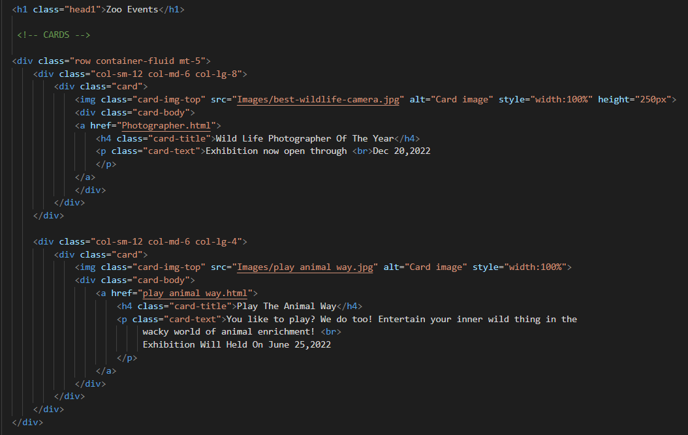

***7.Ticket (ticket.html):***

The ticket Section is included in the website so that user can get and purchase the ticket by clicking on the Buy Now button. Prices are also mentioned for the children and adults etc.

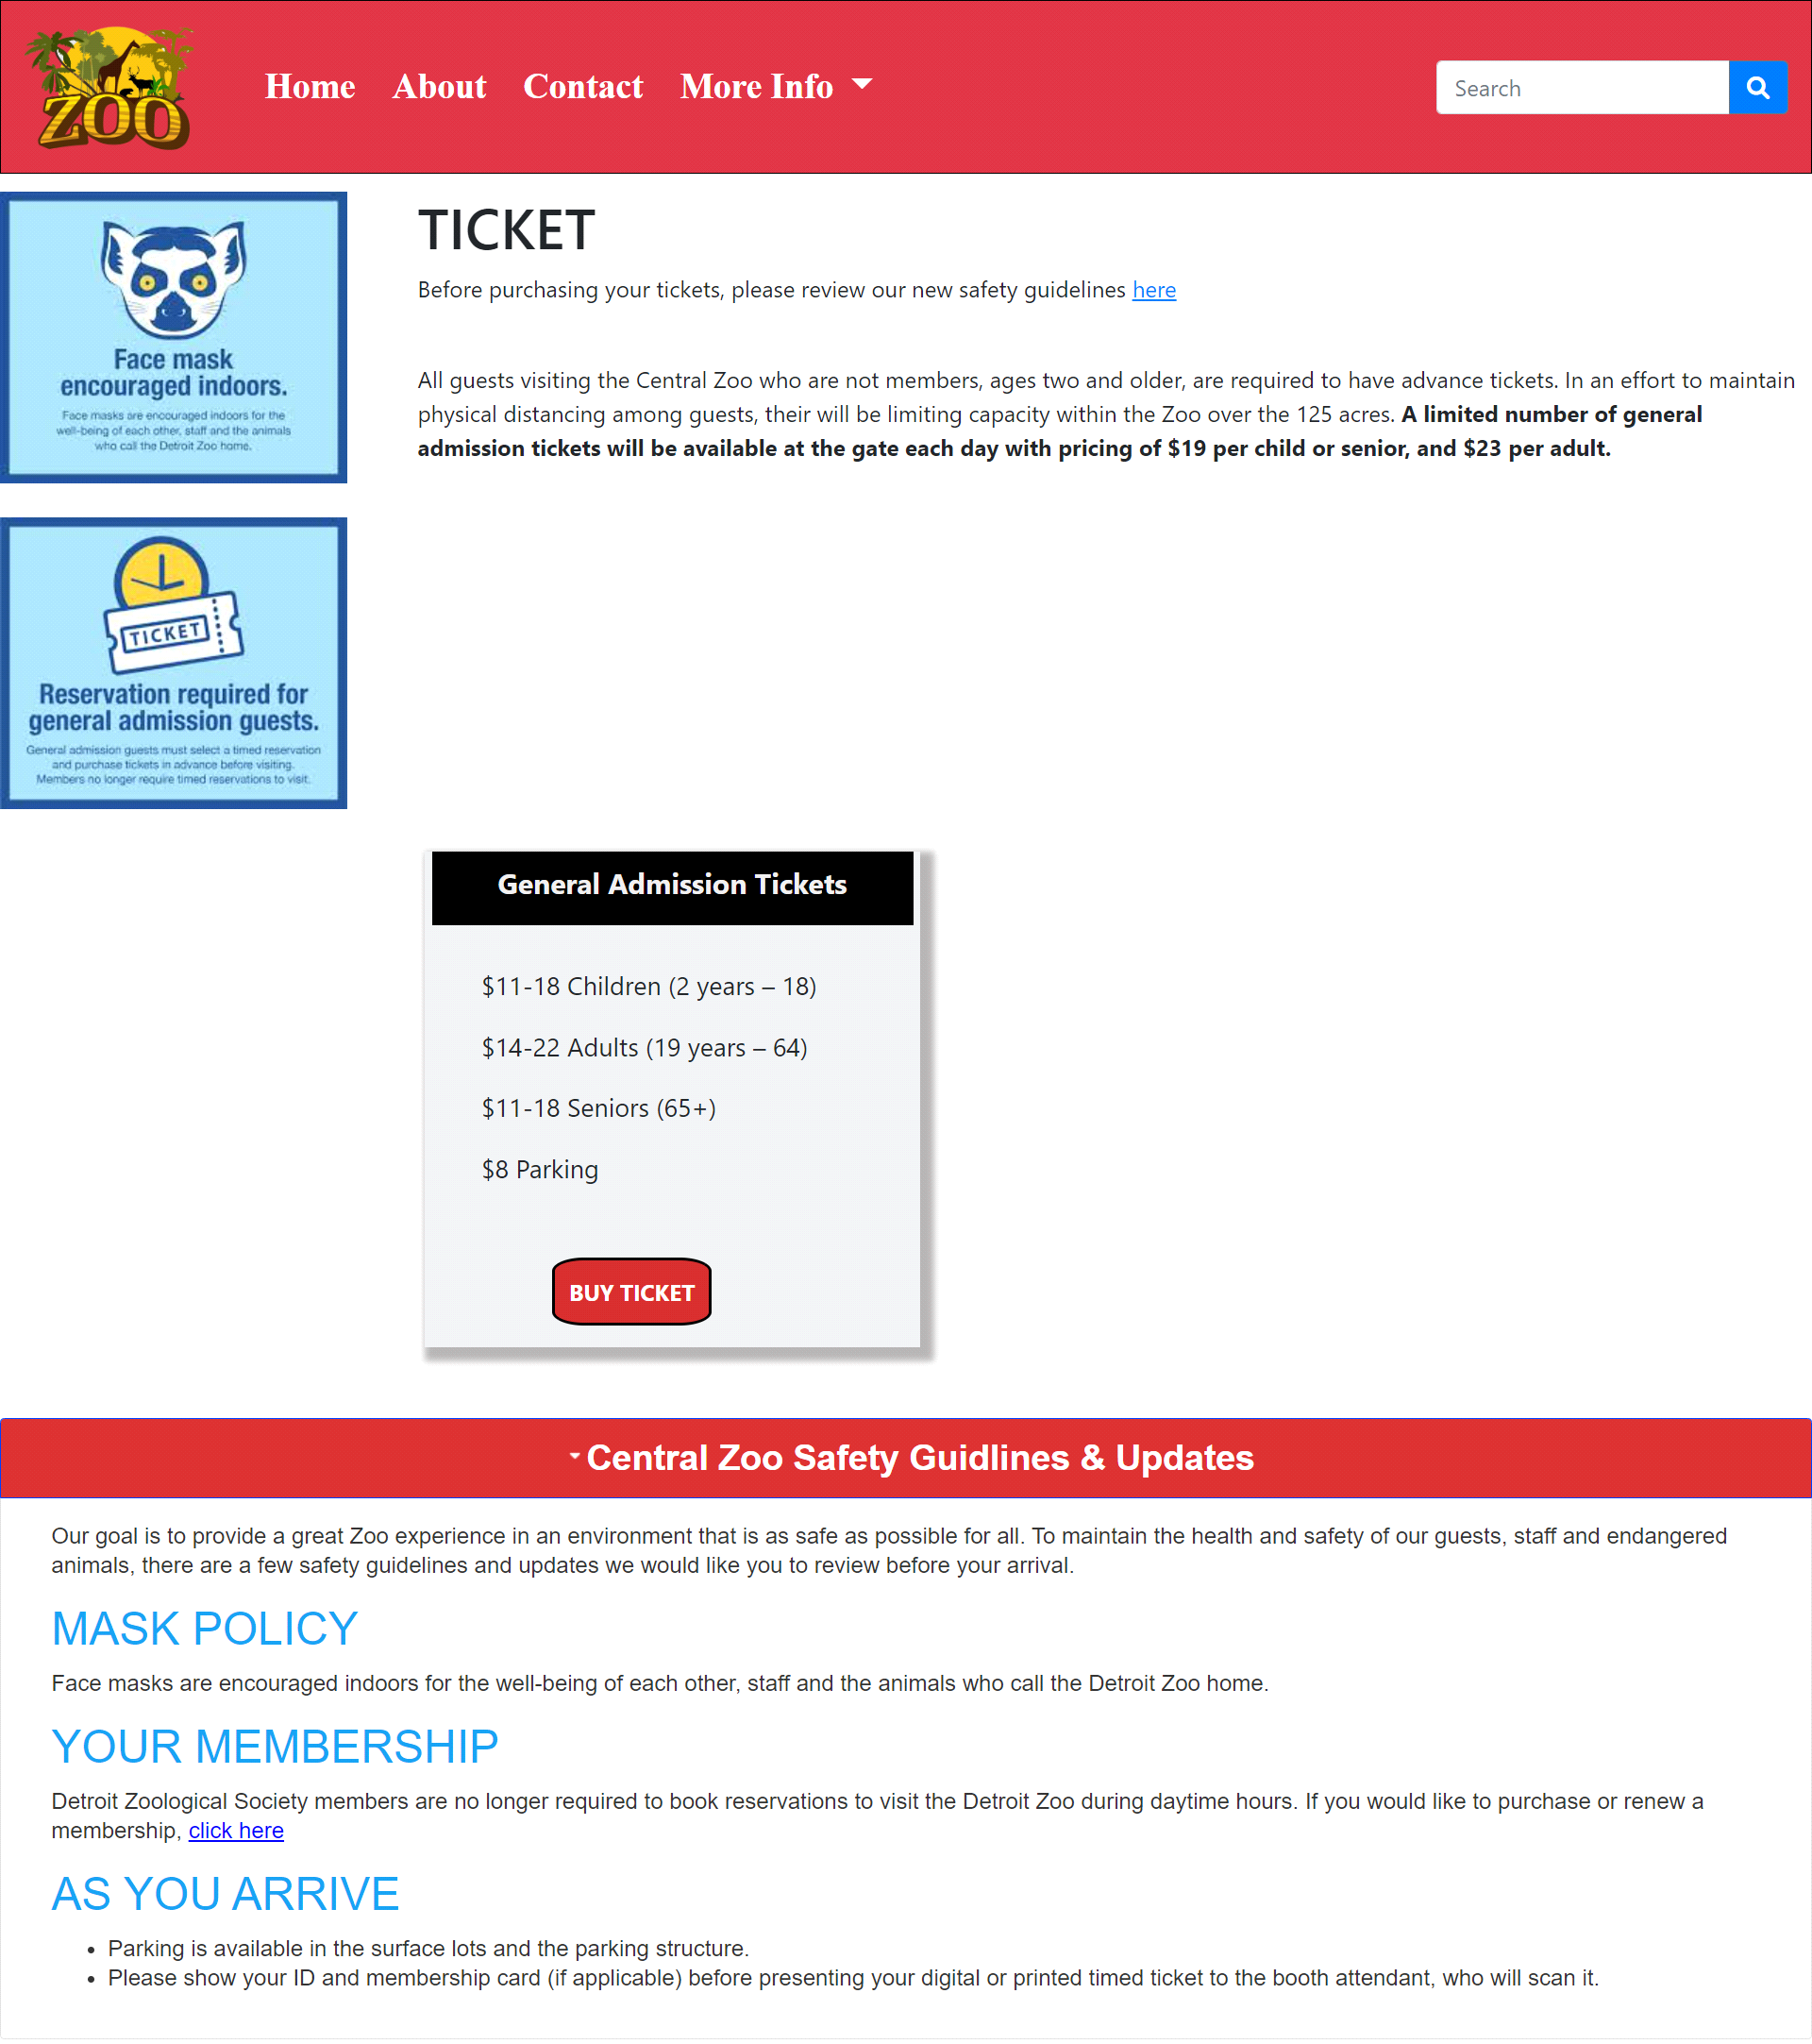

***Figure 7: Ticket***

 In our Ticket page we have given information about the ticket of the zoo and safety guidelines also.

.

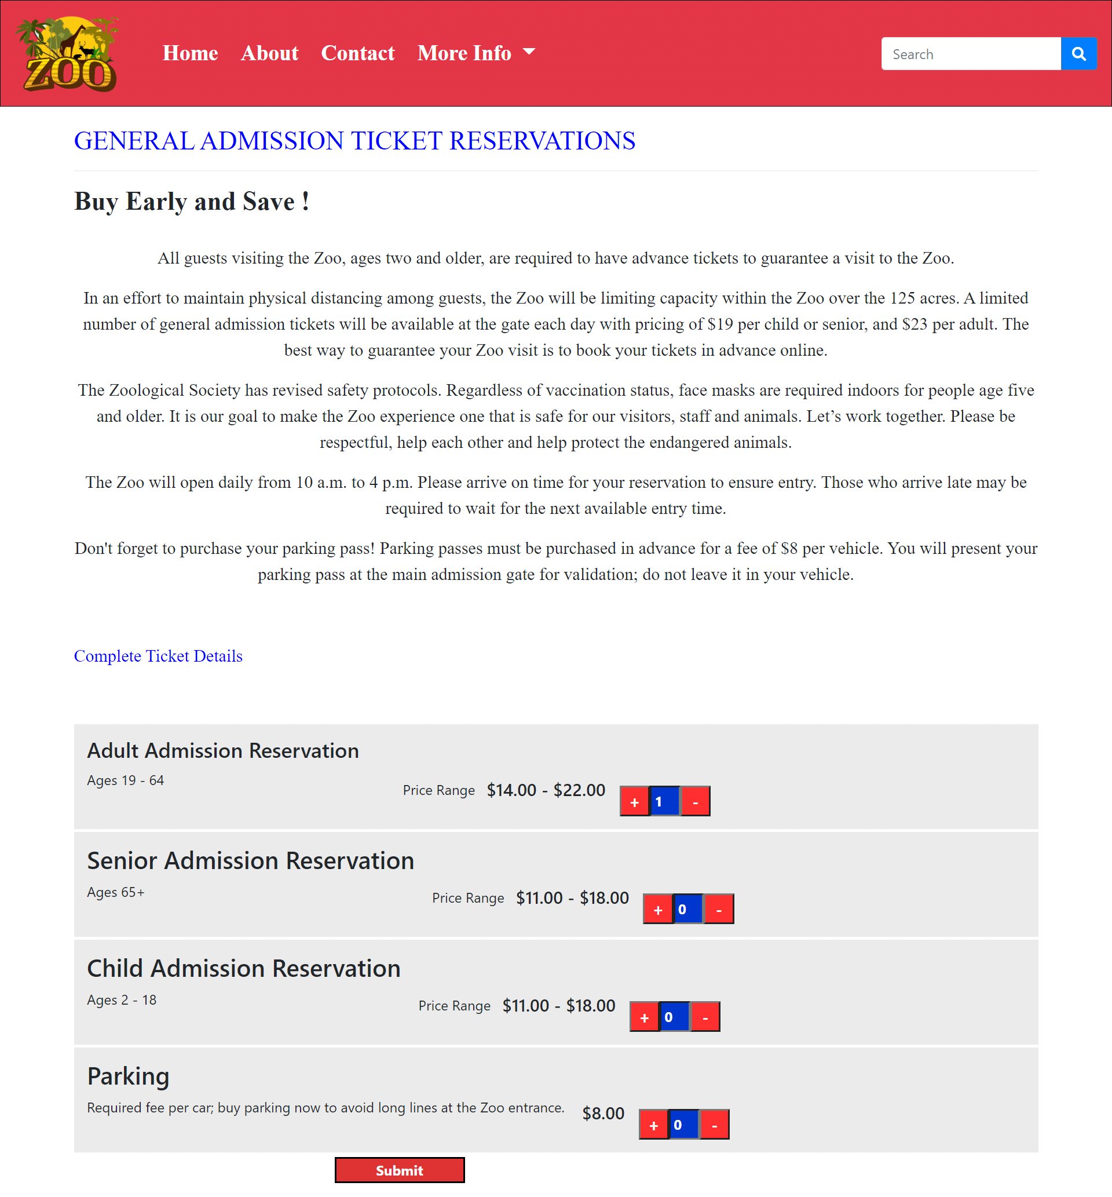

 In our Booking page we have given 3 category of ticket reservation and also avalible for vehicle parking.

***Code of Ticket & Booking***

***Code of Ticket***

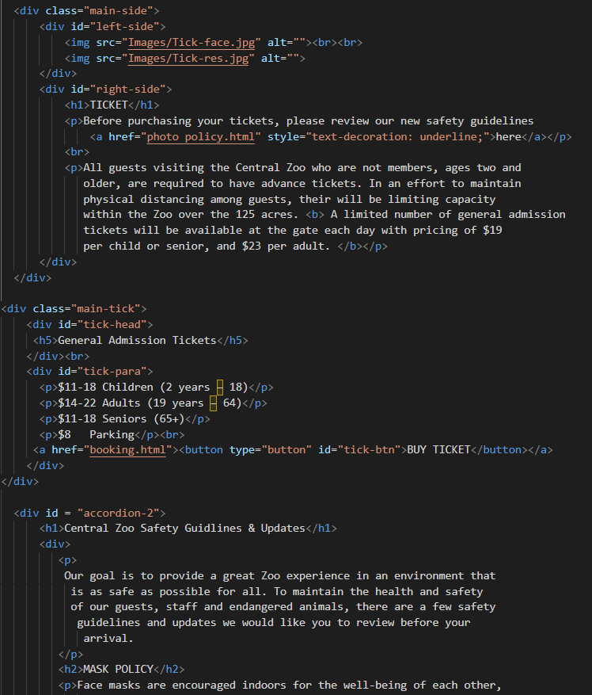

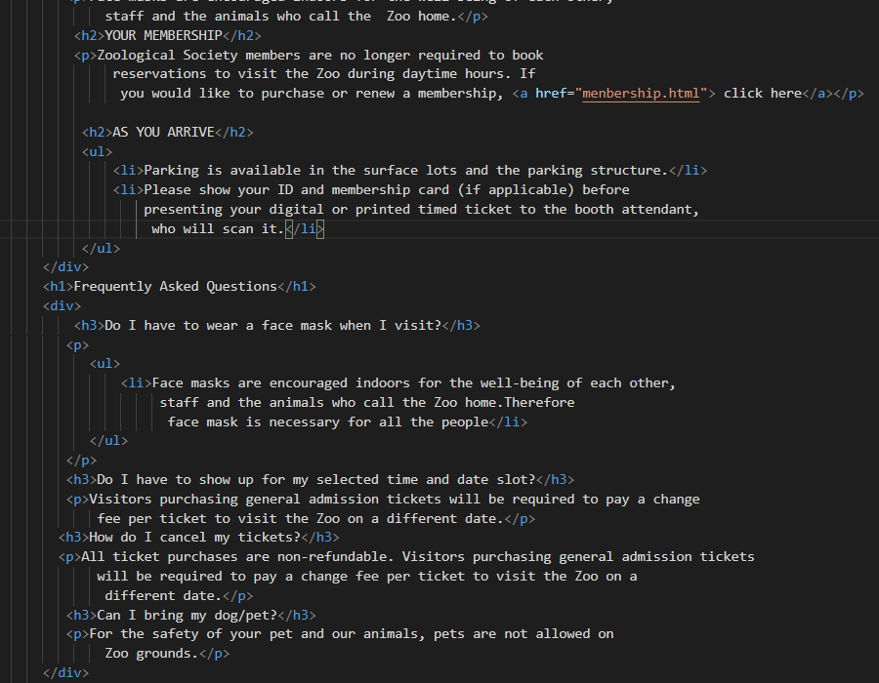

***Code of Booking***

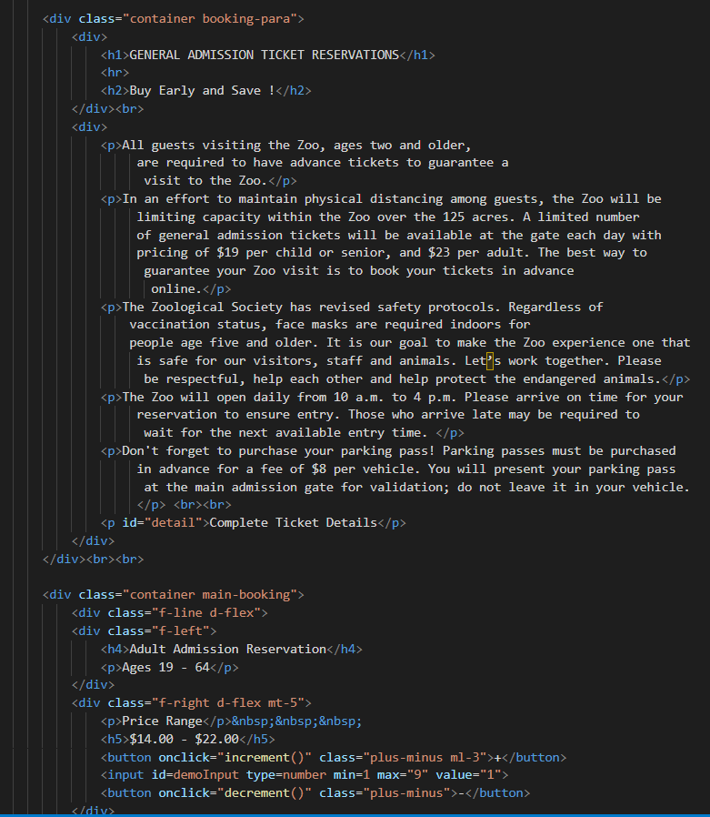

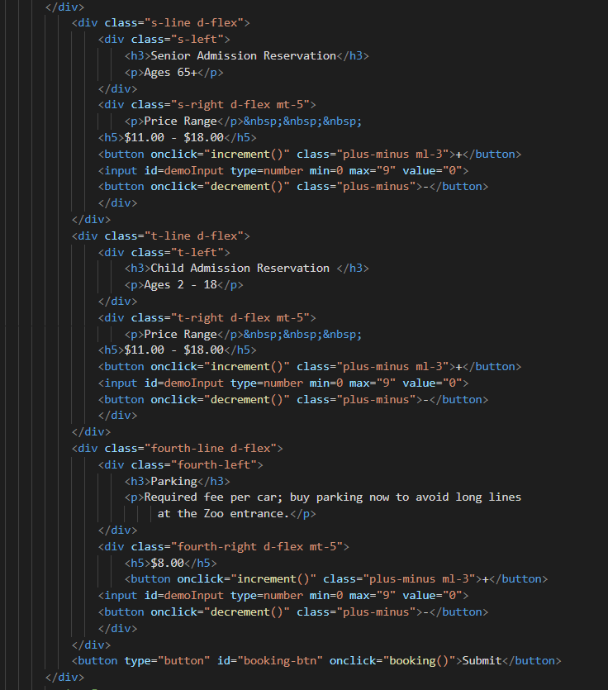

***8.Questions About Zoo (ticket.html):***

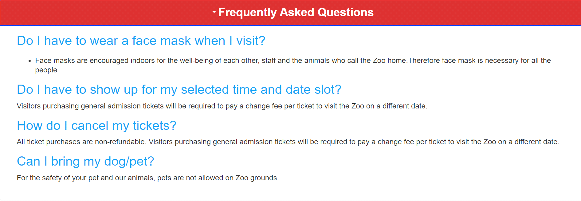

***Figure 8: Questions about Zoo***

If any client has any query about our Zoo so they can have solutions over here

***Code of Question About Zoo***

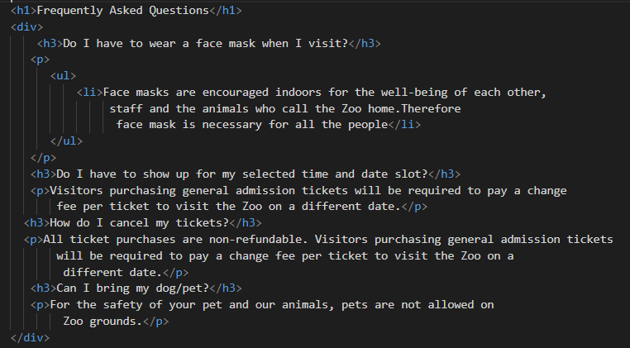

***9.Membership (mambership.html):***

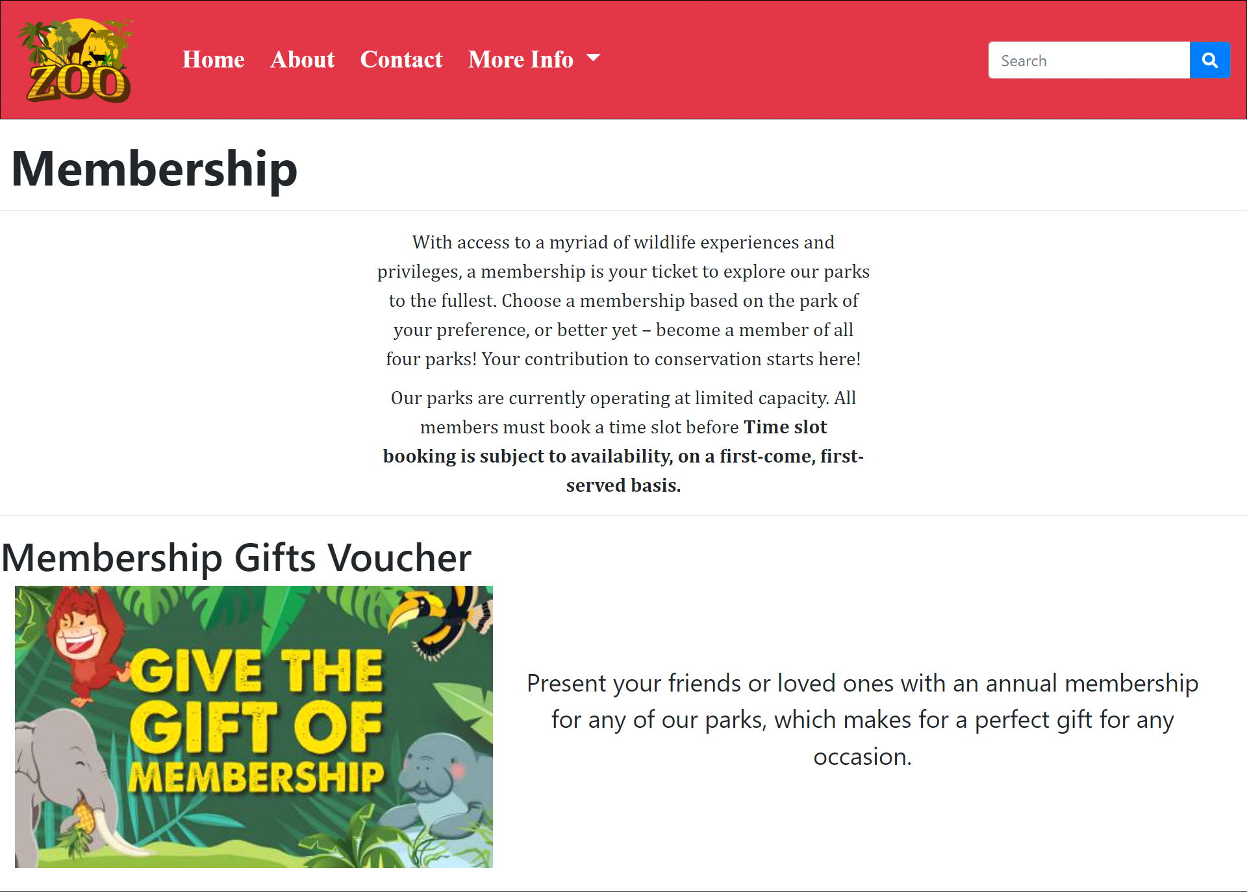

***Code of Membarship***

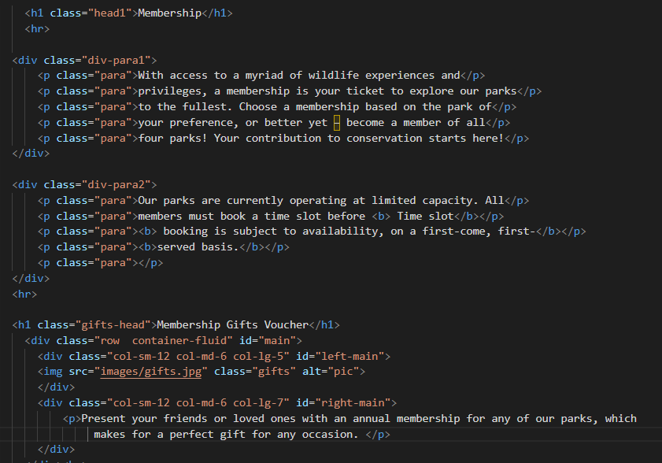

**10.Photo Policy *(photo policy.html):***

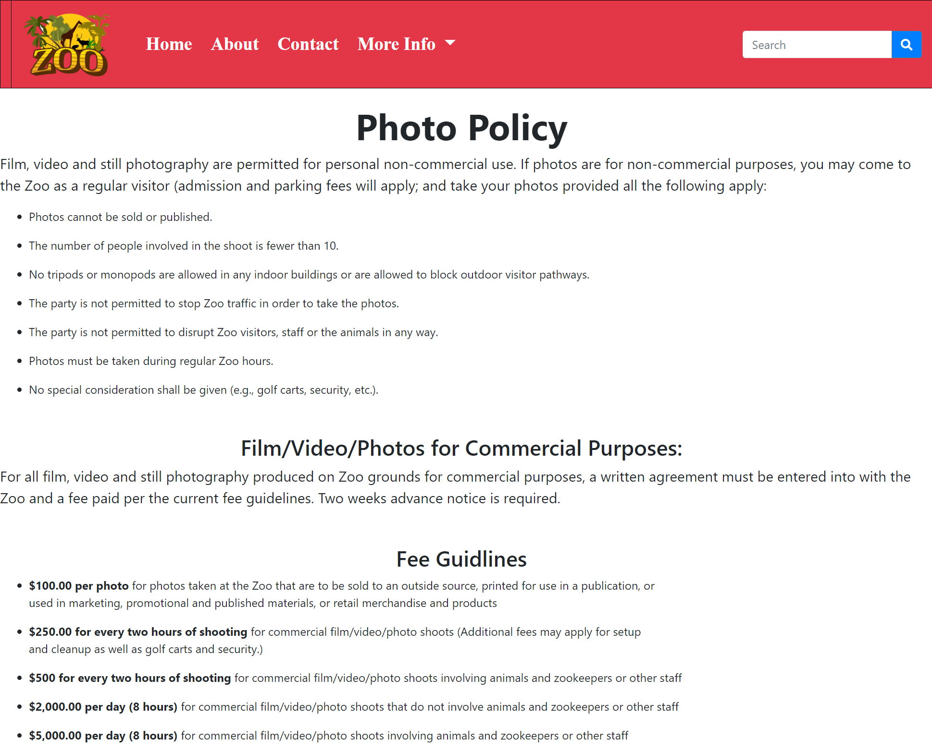

***Figure 10: Photo policy***

All information about photo shoot & video shoot and its policies

***Code of Photo Policy***

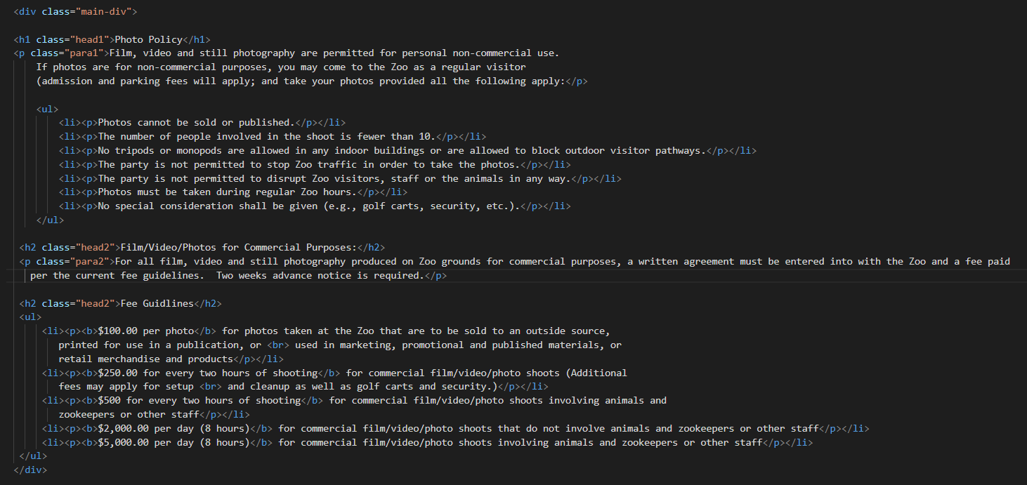

***11.Contact & Feedback (contact.html):***

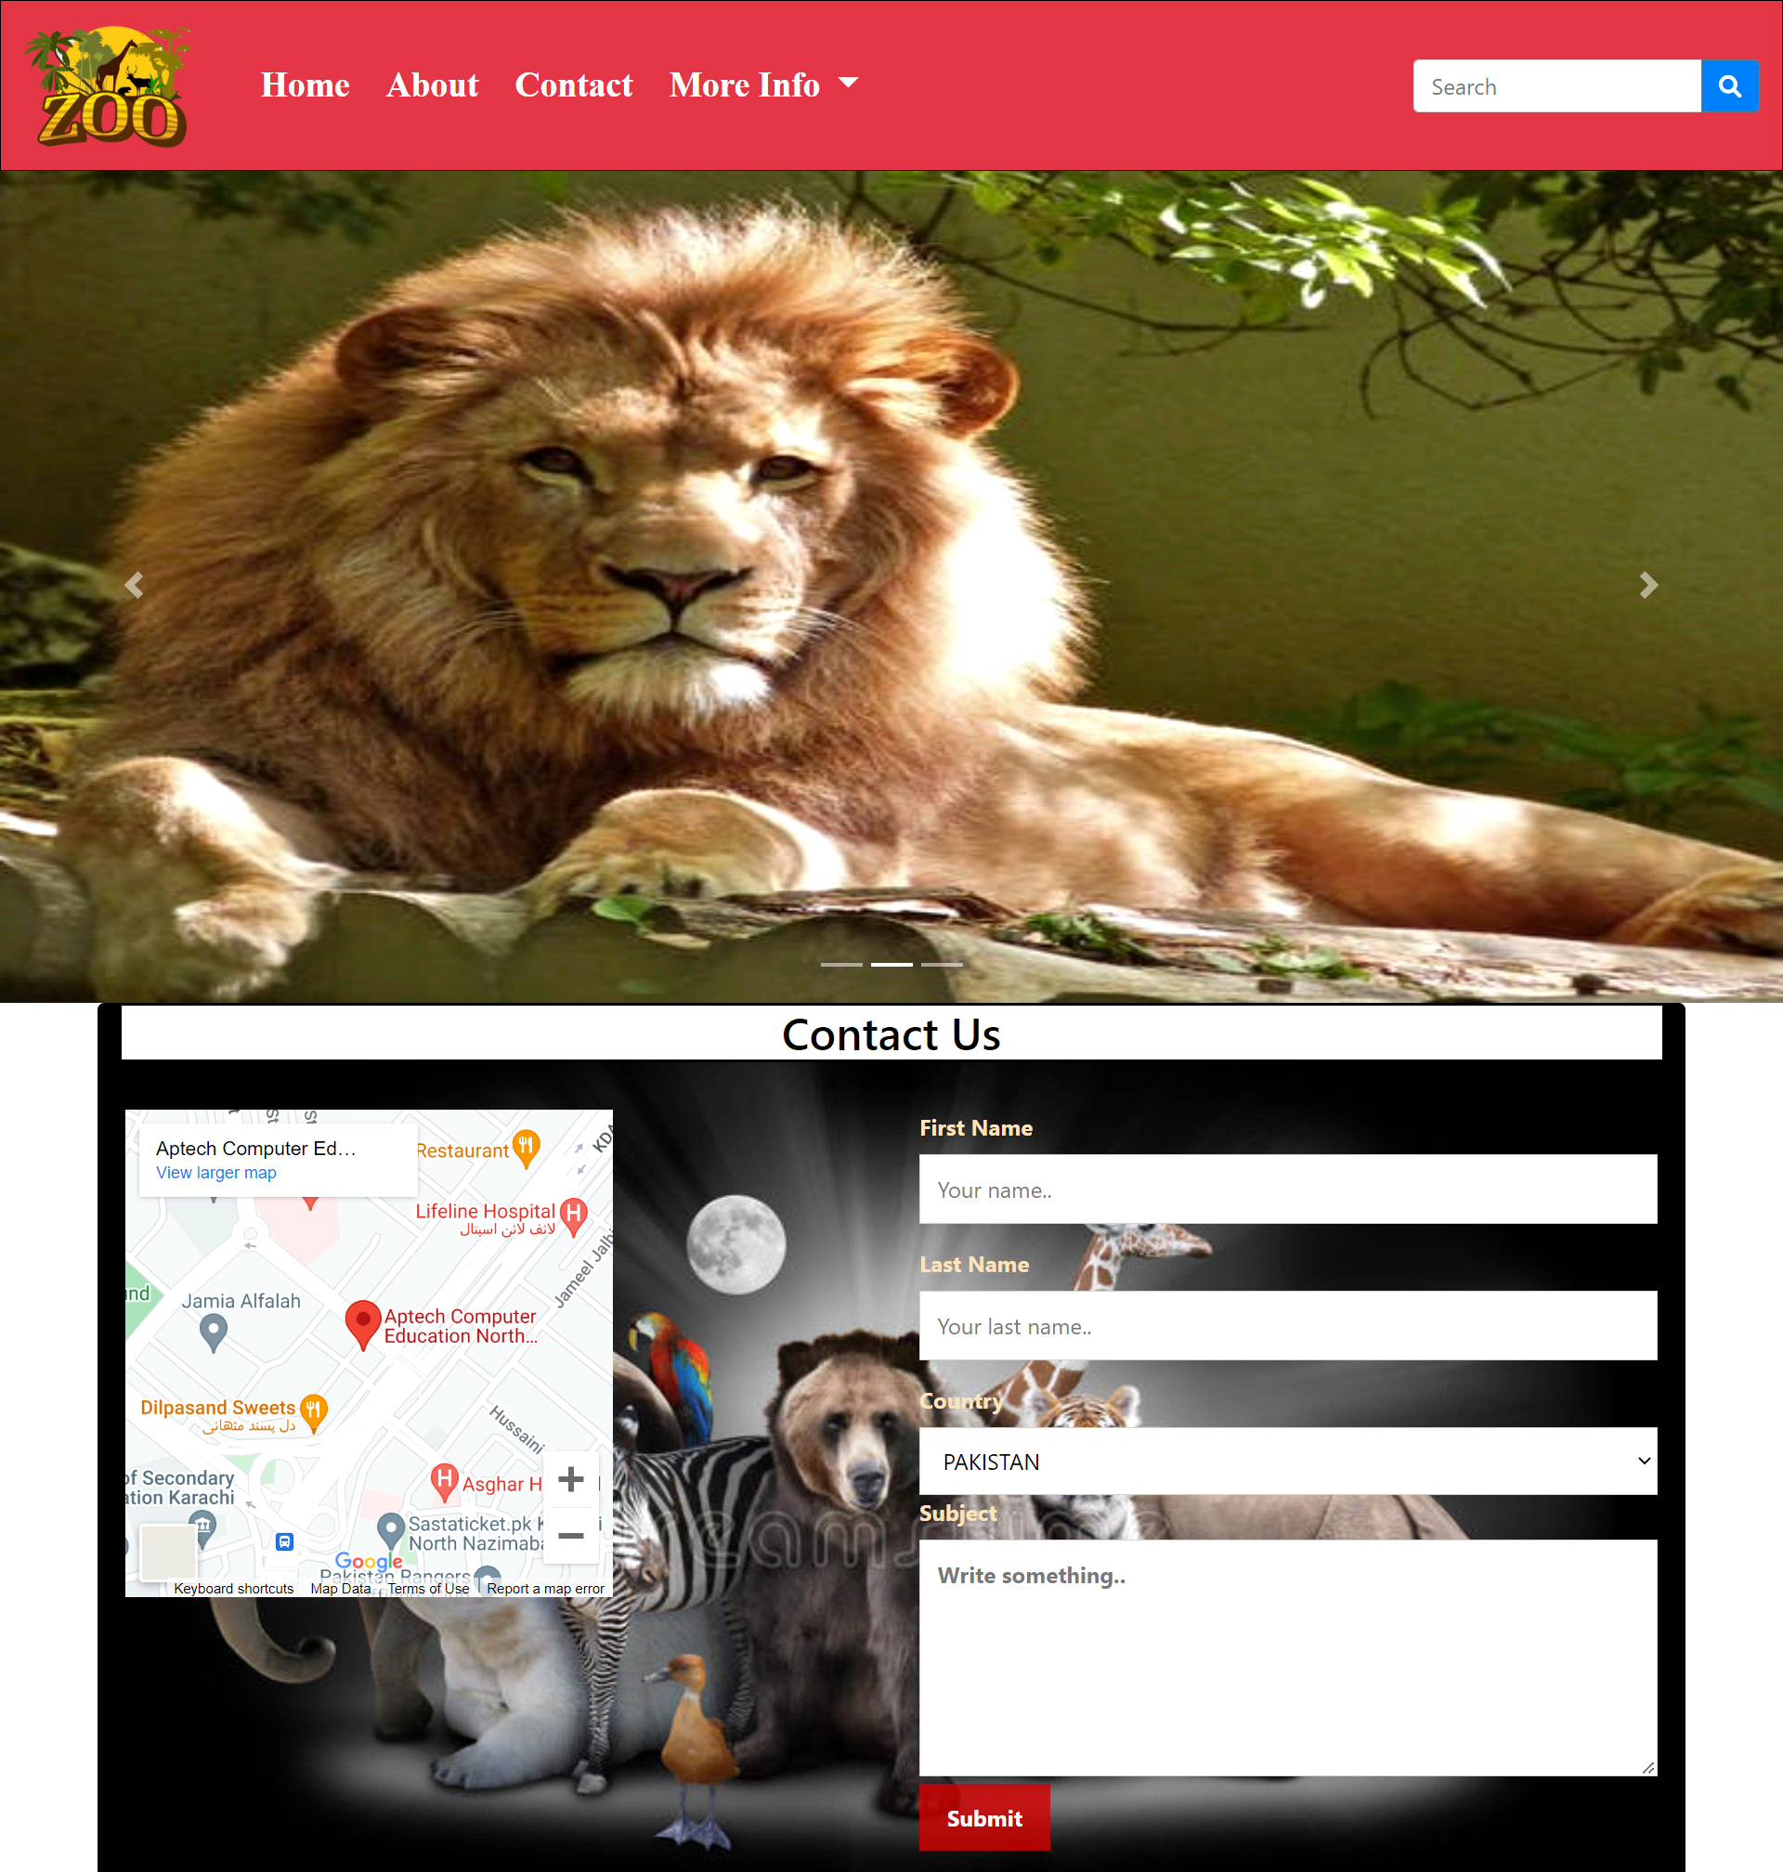

***Figure 11: Contact & Feedback***

*In our contact page we have given location map for the ease of the people*

*Email id and phone number for contacting in case of any problem and get positive feedback.*

*Update Form:*

*Ready To Updated From The Zoo.*

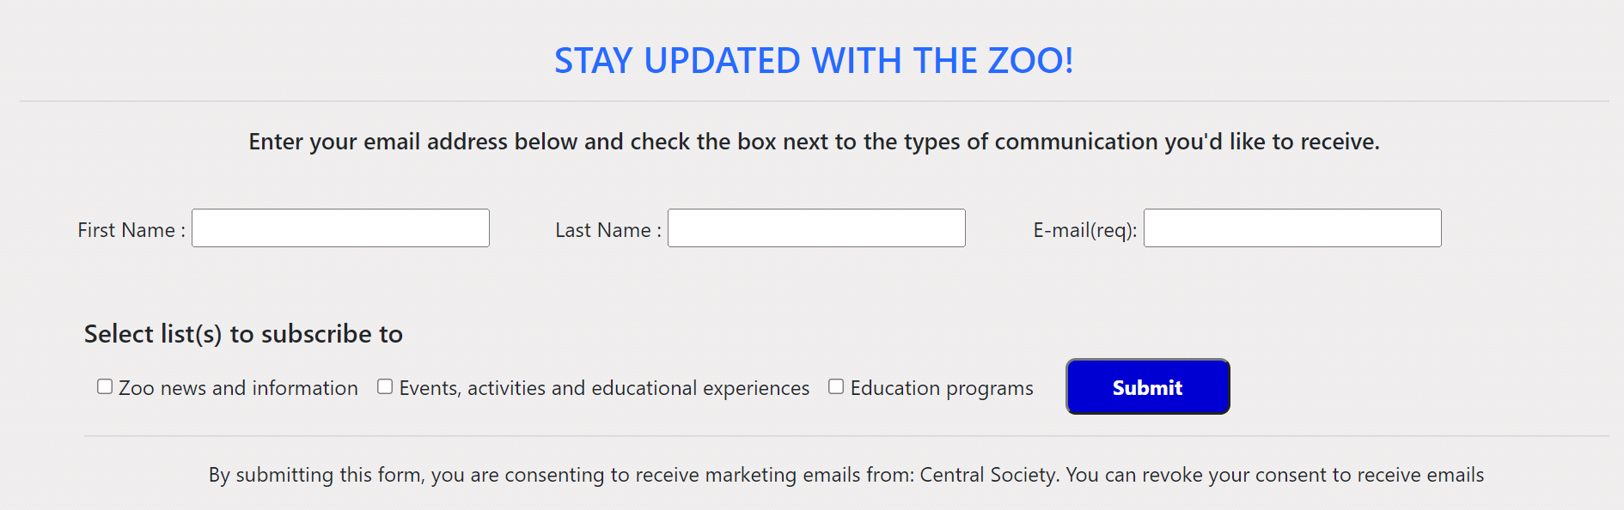

***Code of Update Form***

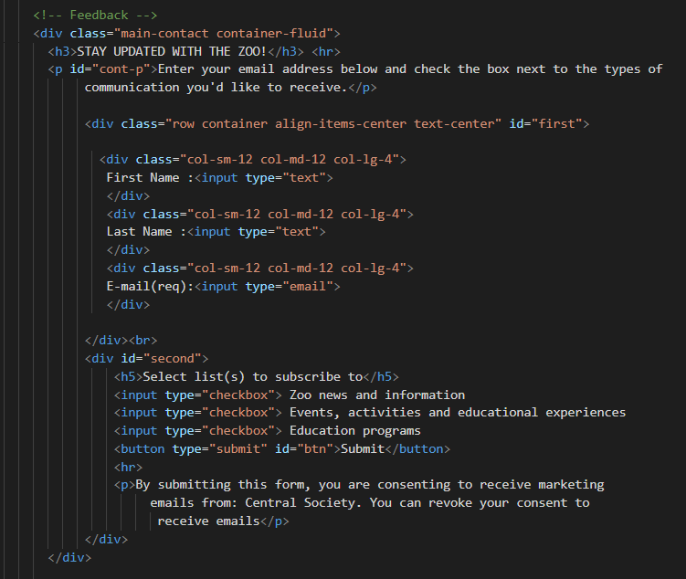

***Code of Contact***

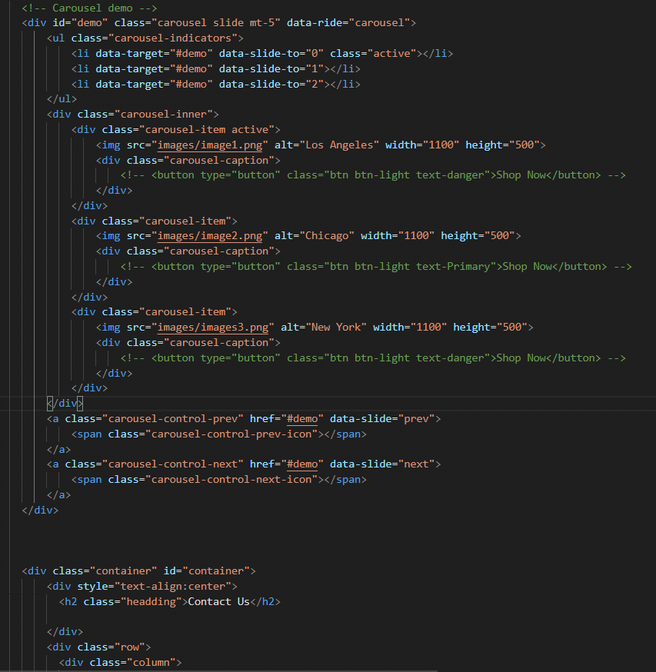

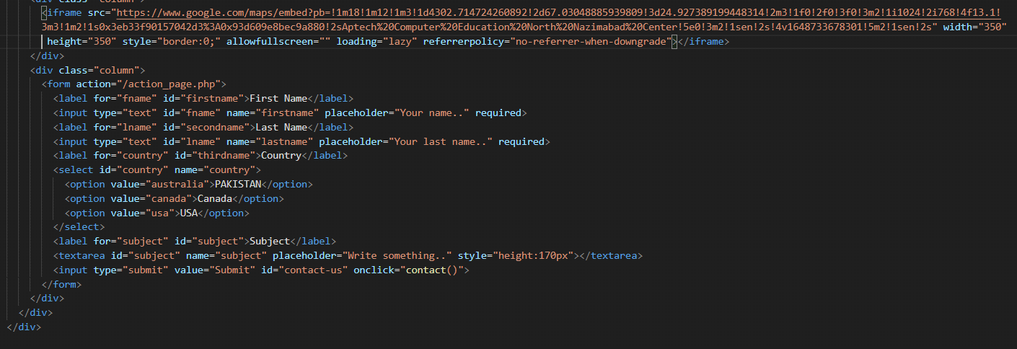

***12 Footer(the zoo.html):***

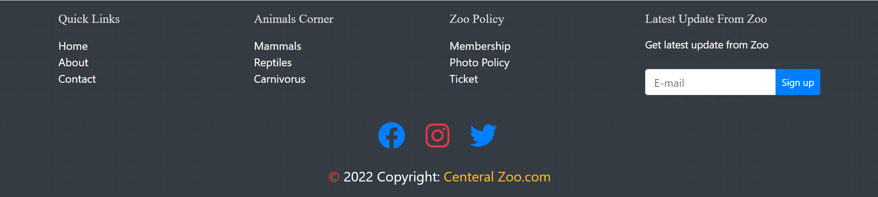

***Figure 12: Footer***

We have given all linked pages to access easily our website

Copyrights are given in the end of the website and effects of Facebook Instagram and twitter are also mentioned to contact and follow us.

***Code of Footer***

